DM-G150 Drone Motor
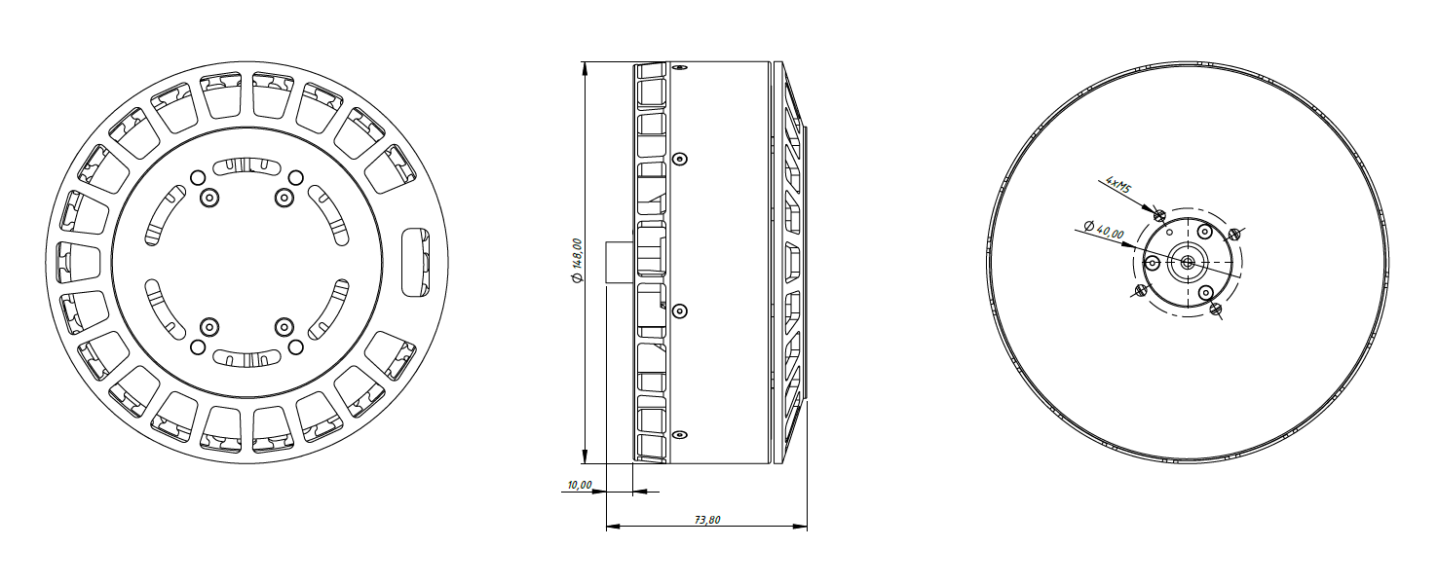
Basic Motor Parameters
Throttle | % | 60
Max. Thrust | kg | 60
Recommended Takeoff Weight | kg | 26-28
Torque | Nm | 21
KV Rating | rpm/V | 45
BUS Voltage | S | 18 S Lipo
Operating Current | A | 55
Rated Speed | rpm | 1700
Propeller Force Efficiency | g/W | 8
Electrical Parameters
Number of Phases |  | 3
Number of Poles |  | 42
Terminal Resistance Phase to Phase (±%10) | mΩ | 18
Terminal Inductance Phase to Phase (±%30) | mH | 35
Thermal Data
Ambient Temperature | °C | -40...+85
Max. Winding Temperature | °C | +155
Physical Parameters
Outer Diameter | mm | 150
Shaft Diameter | mm | 15
Weight | gr | 3280
Motor Connection
U | RED
V | BLACK
W | WHITE
Sensor Connection
N/A | N/A
Connector Articles
Power | N/A
Signal | N/A
Propeller Info (Recommended)
Diameter | 56”
Pitch | 20”

